- Given a dataset of YouTube influencers with their number of followers (independent variable) and average monthly brand deals (dependent variable), identify which variable is dependent and which is independent. Explain your reasoning in 2-3 sentences.
ANSWERS:
The number of followers is the independent variable because it can influence how many brand deals an influencer receives.
- Using any spreadsheet tool (Excel, Google Sheets) or Python (pandas), plot a scatter plot of Myntra ad spend (in lakhs) vs. number of app downloads for 10 sample data points. Visually draw or highlight the line of best fit on your plot.
ANSWERS:
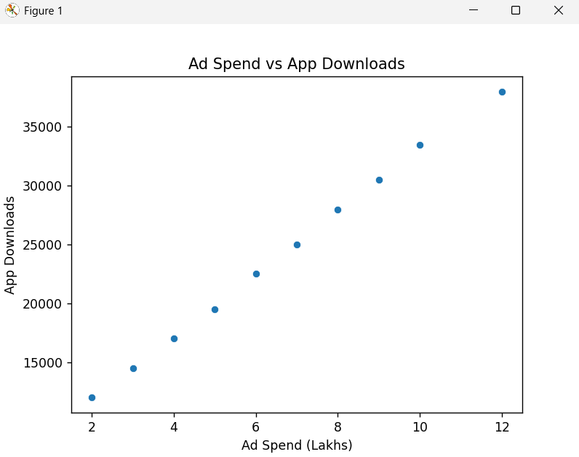
- Using Python and scikit-learn, fit a simple linear regression model to predict the average daily orders on Swiggy based on daily advertising spend. Print out the slope (coefficient) and intercept, and explain in your own words what each means in this context.
Hint: The coefficient tells you how much orders increase for every extra lakh spent on ads.
ANSWERS:
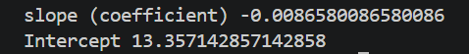

- Calculate the R-squared value for your regression model in the previous task and interpret what it tells you about the relationship between Swiggy's ad spend and daily orders.
Hint: Is the R-squared closer to 0 or 1? What does that mean for your model's accuracy?
ANSWERS:

